HONEY BALSAMIC SHEET PAN CHICKEN
Serves 4 to 6
Prep Time: 10 minutes
Total Time: 1 hour 10 minutes

INGREDIENTS
- ¼ cup balsamic vinegar
- 6 tablespoons honey
- 2 to 3 tablespoons olive oil, divided
- 2 cloves garlic, minced
- 1 teaspoon dried thyme
- ¾ teaspoon dried rosemary
- ½ teaspoon red chili flakes
- ¾ teaspoon kosher salt
- ¼ teaspoon black pepper
- 2 pounds chicken breasts (4 each), trimmed
- 1½ pounds baby red potatoes, quartered
- 1 pint cherry tomatoes
- 1 pound green beans, trimmed

DIRECTIONS
  - Preheat the oven to 425 degrees Fahrenheit (175 degrees Celsius).
  - In a medium bowl, combine the balsamic vinegar, honey, a tablespoon of olive oil, garlic, thyme, rosemary, chili flakes, salt and pepper. Stir well to mix.
  - Place the chicken breasts in a resealable plastic bag and pour the marinade over the top. Seal and toss the chicken to evenly coat. Marinate for at least 30 minutes.
  - While the chicken marinates, place the potatoes and cherry tomatoes on a sheet pan. Drizzle with the remaining olive oil, season with salt and pepper, and stir to coat. Bake for 25 minutes.
  - Remove the sheet pan from the oven and toss the green beans with the potatoes and tomatoes.
  - Remove the marinated chicken breasts from the plastic bag, reserving the remaining marinade in the bag. Place the marinated chicken, evenly spaced, on top of the vegetables. Pour the marinade from the bag over the top of the chicken and vegetables.
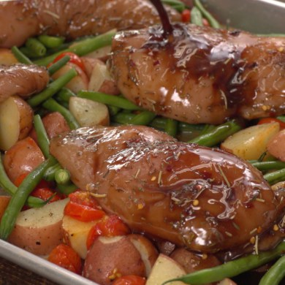
Lauren von Hagel | TipHero
  - Return the sheet pan to the oven. Bake for 30 to 40 minutes, periodically basting the chicken breasts with the pan juices, until the internal temperature of the chicken reaches 165 degrees Fahrenheit (74 degrees Celsius).
  - Allow the chicken to rest for 5 to 10 minutes. Spoon the pan juices over the top of each chicken breast before serving.
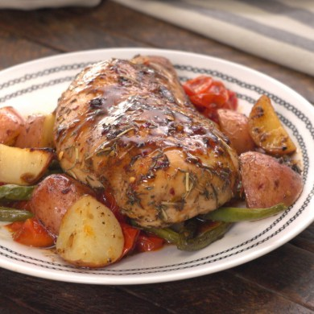
Lauren von Hagel | TipHero
http://tiphero.com/honey-balsamic-sheet-pan-chicken/
Sent from Ray's iPhone 6+ 🐓

